# Data Collection

## Samples

* Part of a Population

## Parameter

* Factual information about **population**

## Satistics

* Can be computed to **estimate parameter**

## Accuracy

* How close is the **estimate statistic** to the actual **true parameter**

## **Bias**

* Factor that allows unequal variations of probability among **responses or samples** (intended or not)

### Selection Bias

* + When there is **underlying nature** in **determination** of **sample for study**

### Measurement bias

* + Recall bias
  + Sensitive bias
  + Misinterpretation bias
  + Wording bias

## Testing Methods

## Double blind test

* + Testing method where both **investigator & subject** go into test without knowledge of **what group anyone is in**

## Observational study

* + When investigator **observe** the effect of **risk factor/treatment** without trying to change or control **who is and isnt exposed to it**
    - Smoking vs non-smoking impacts

## Confounders

* **Dependant variable** that was not considered

### Method to control confounders

* + - Divide up the groups with respect of confoudner

## Simposons paradox

* When a clear trend in **individual groups** either **dissapear or reverse** when groups are pooled together
  + Clear sign of existance of confounder

# CHI-SQUARE

## General Structure of Report Layout

It is always **One sided test** where because we are looking for SIGNIFICANCE relationship

### H­0 Null hypothesis

* Conventional belief/ No statistical significance between factors

### H1 Alternative Hypothesis

* What you are trying to prove/ Existance of statistically significant relationship between factors

### Assumptions

* Facts about the population that is assumed to be true.

### Test statistics

* Numerical value that provide information about **General lnature of sample**
* Deviation away from expected parameters.

### P-Val

* Probability that we observe a **test statistic** that is **as or more extreme** than our observation

## Degree of Freedom

Number of freely determined cell

## Goodness of fit

Study to test one categorical factor and it’s frequency against eachother.

### Hypothesis

H0 : Frequencies acrross all categories in a factor is the same

H1: There is at least one group is not the same. There exists a where

### Assumptions

* Each observation is chosen at random from population and is independent from eachother
* Expected frequency per category is 5

### Test statistics

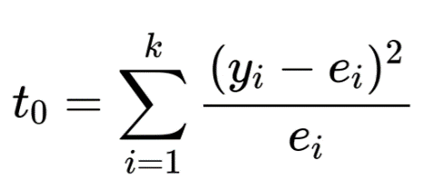General equation that tries to test whether

Significance is present between **expected frequency vs observed frequency** per each **Factor Categories**

### P-Val

P( where k = number of categorie

## R Examples

Two methods in R

1 – pchisq(t0, df = (degree of freedom))

Chisq.test(y, p = c(probabilities))

# Poisson Distribution

Poisson random variable represents the probability of a given number of event occuring in a fixed interval **GIVEN** their independence and with known average rate **λ**

## Hypothesis

H0: Sample comes from a **poisson distribution**

H1: Sample does not come from **poisson distribution**

## Assumption

* Each observation is chosen at random from population and is independent from eachother
* Expected frequency per category is 5

## Test Statistics

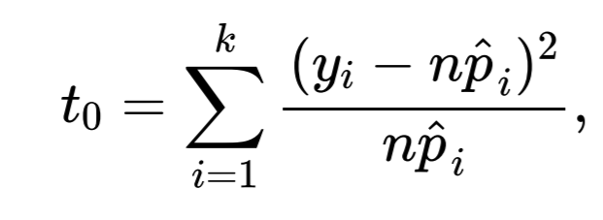 given 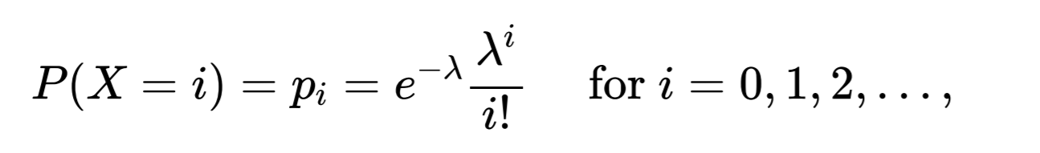

Where **λ = Sample mean**

## P-Val

* Degree of freedom is k-2 because we made an assumption on a parameter **λ**

## Example



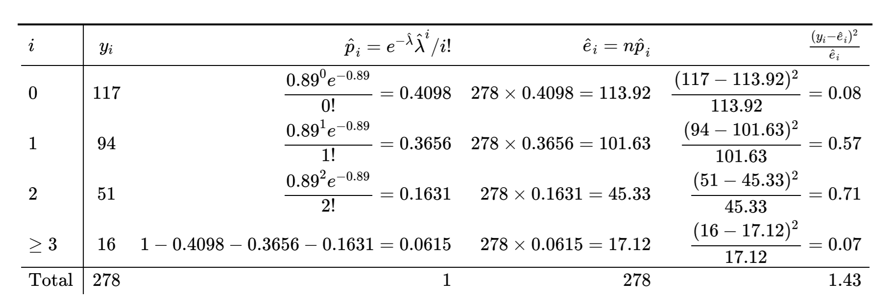

# Types of Errors

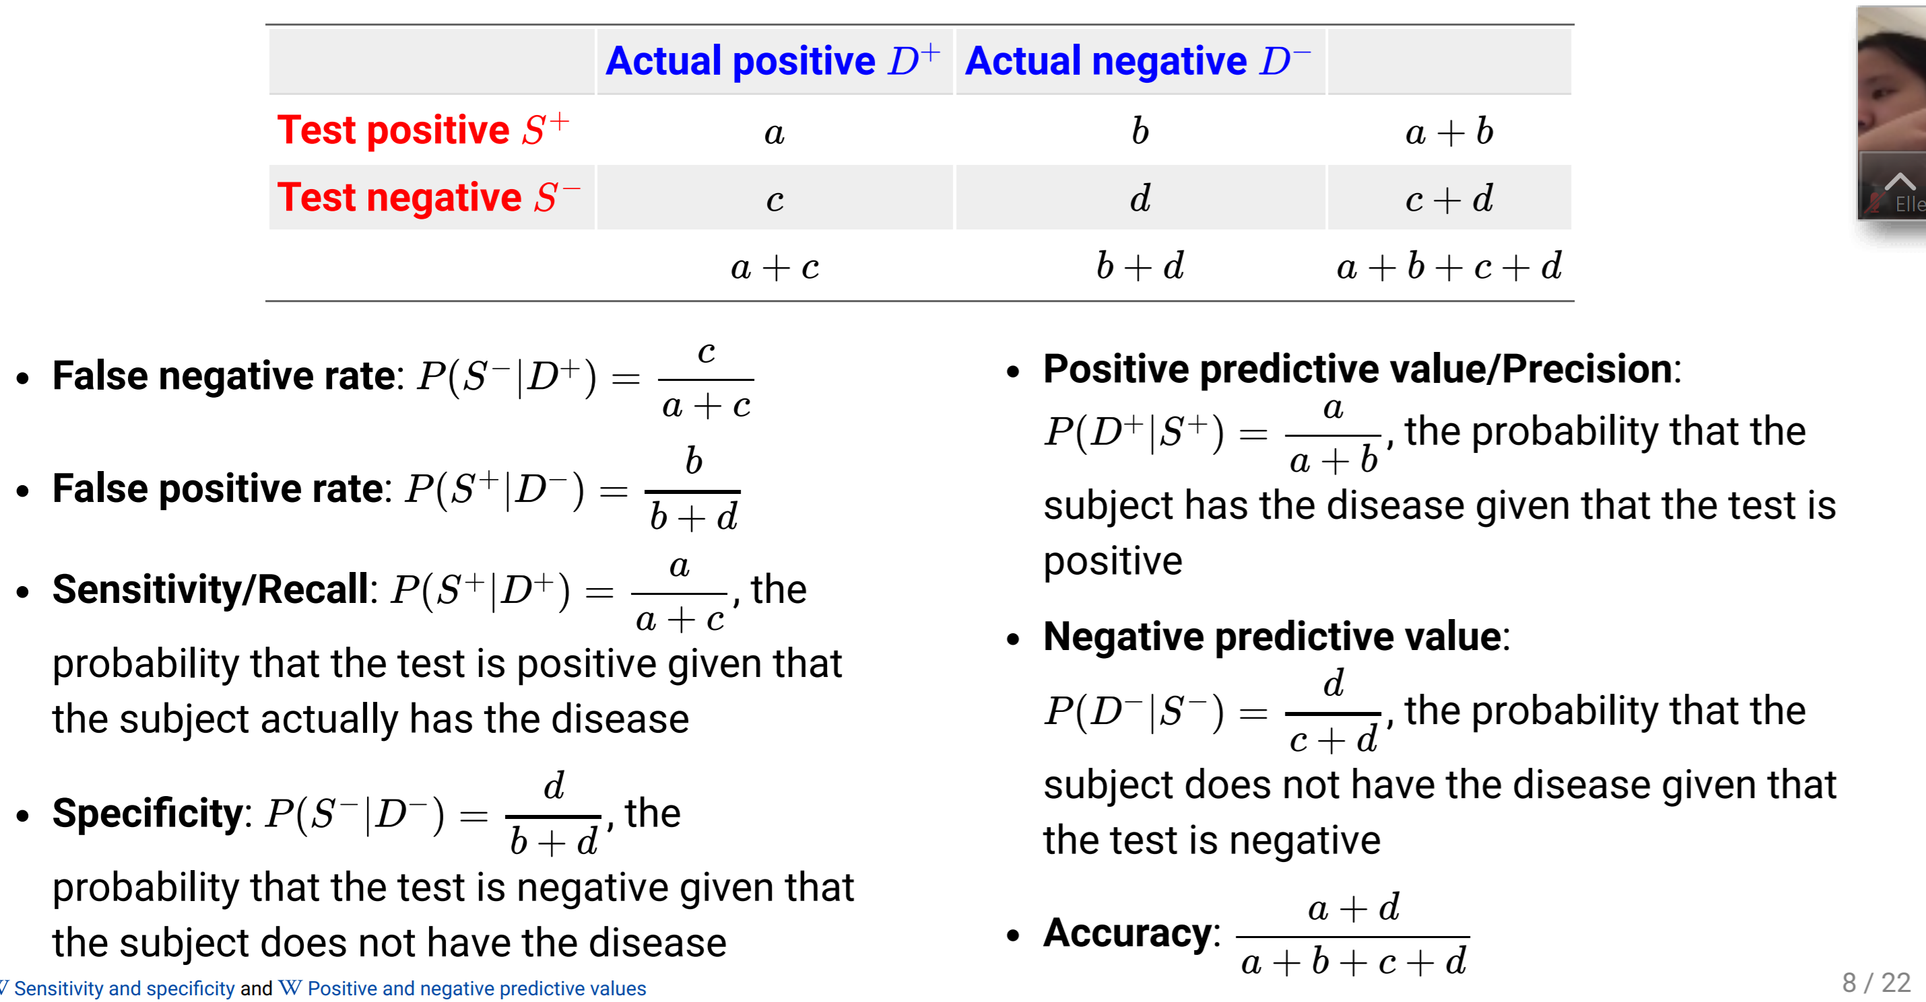

# Conditional Definition

Probability of A **GIVEN** event B Occurred

## Bayes Rule

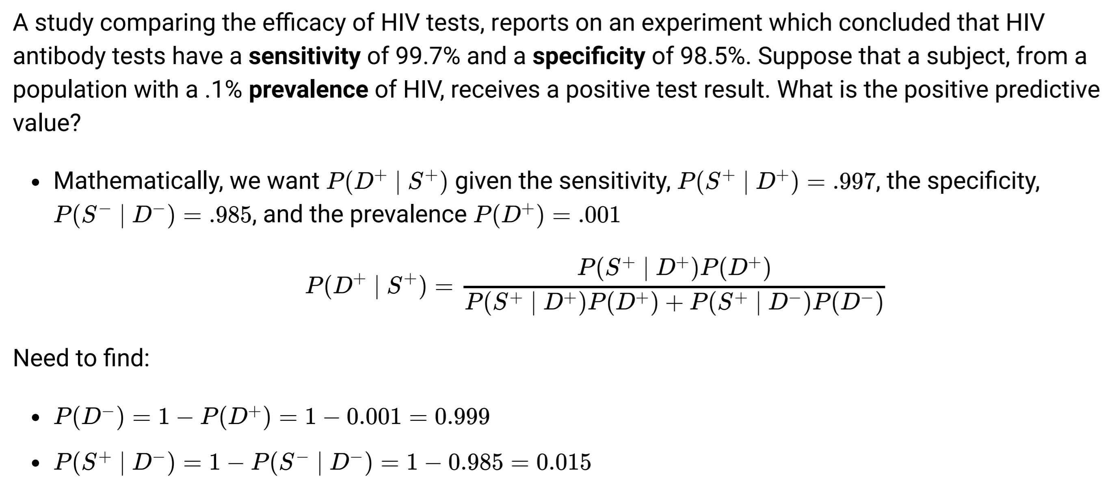

# Measurement of Risk

## Prospective Study

* Stidies based on **subject** who are **initially identified disease free** and **classified by their exposure to risk factor**, they are then observed **through time** to see whether they **become diseased or not**
* Difficult to do because of ethics
* or

## Retrospective Study

* Study based ob **random sampling** from each of the **category groups** and through **interogative research** observe their exposure to **risk factor**
* or

## Relative Risk

* Ratio of Probability of **having the disease** **GIVEN** exposure to **risk factor** to probability of not
* Only applicable for **prospective studies**

If the Risk factor is independent from **presence of Disease** then RR should be 1.

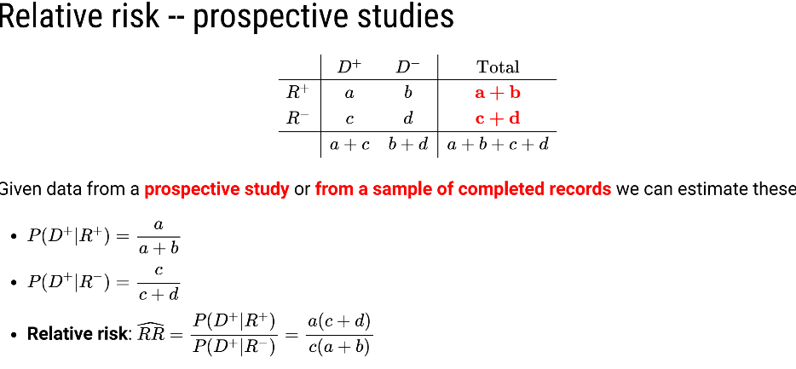If:

RR > 1: Disease is **more** likely from group **with risk factor**

RR = 1: Disease and Risk factor is independent

RR < 1: Disease is **less** likely from group **with risk factor**

## Odds

* Ratio of Diseased/Non-diseased **given** the presence of Risk factor.
* Applicable for both **prospective and retrospective**

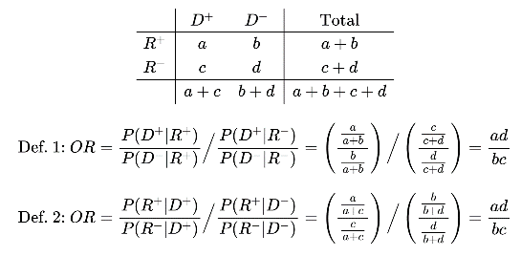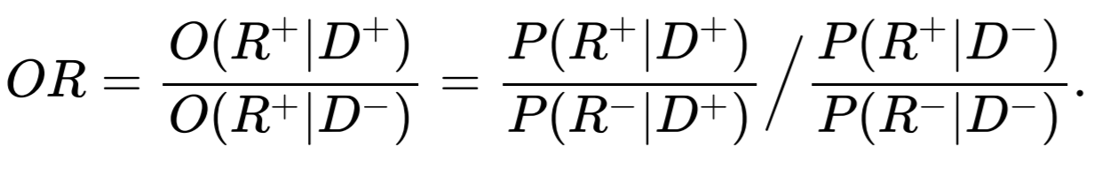

OR > 1: Disease is **more** likely from group **with risk factor**

OR = 1: Disease and Risk factor is independent

OR < 1: Disease is **less** likely from group **with risk factor**

## Confidence interval and Standard Error

SE(log(OR)) =

Log(OR) ± 1.96 * SE(log(OR))

# Testing for Homogeneity

## Hypothesis

H0: All the categories’s probability is the same, P11 = P21 & P12 = P22

Probability distribution of Categories are the same over **Two different population**

H1: At least one categorical relationship is significantly different, P11 ≠ P21 & P­12 ≠ P22

## Assumptions

* Each observation is chosen at random from population and is independent from eachother
* Expected frequency per category is 5

## Test Statistics

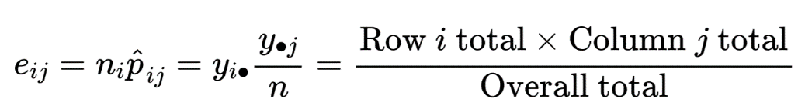

## P-Val

where r,c = number of category per factor

## R Code Example

**Built in R function**

Tab = table(category1, category2)

Chisq.test(tab)

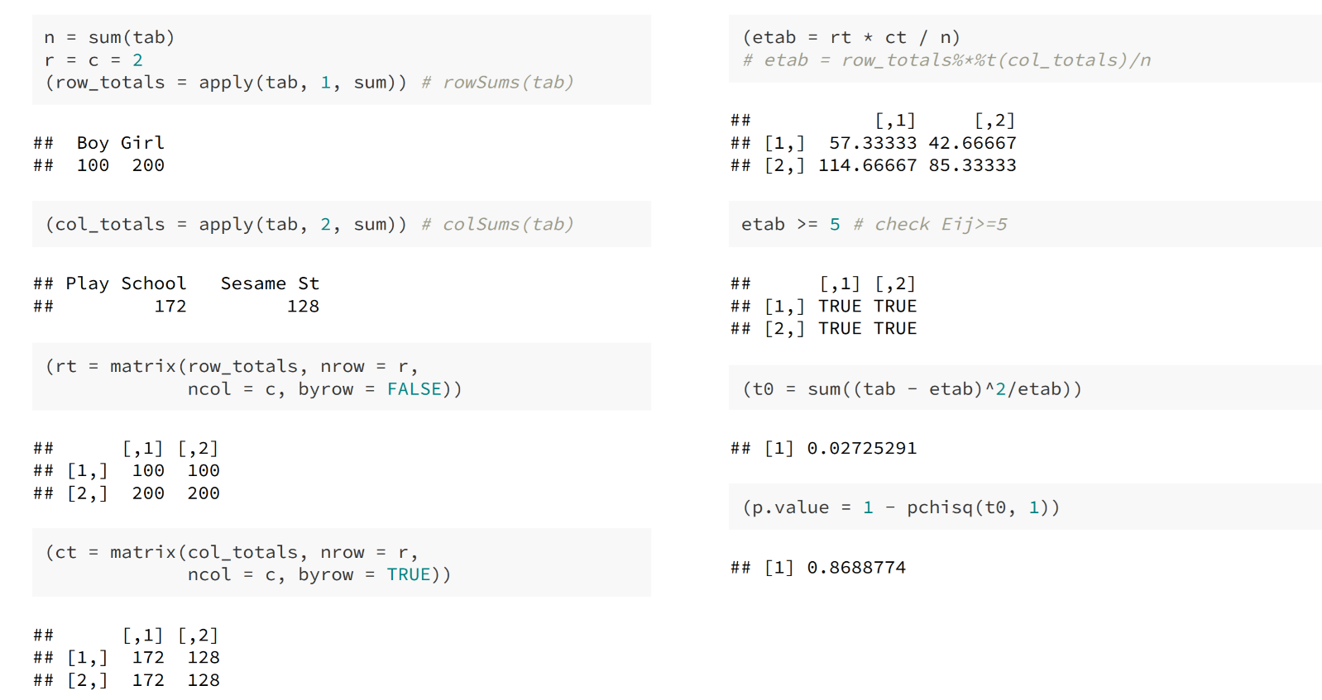**Manual** **Method**

# Test for Independence

## Hypothesis

H­0: Frequency for all the categories are the same Pij = PiPj, for I = j = 1,2,3,4….

Probability distribution of Categories are the same over **different Categories**

H1: Not all Equality hold

Test for Independence and Homogeneity is essentially the same with same processes. **HOWEVER** Differs by the main focus of sample

**Test for homogeneity**

* Analaysis onto whether **One categorical variable** holds **same distribution** over **Two different populations**
  + Sample is **randomly selected** from **two different population**

**Test for independence**

* Analysis onto the underlying nature of the **dependence relationiship** between **two variables OF THE SAME POPULATION**
  + Sample is selected **from one population**

# Tests in a small sample size

## Fisher’s exact test

* Use of **Hypergrometric distribution** to calculate the probability of getting **same or more extreme observation** than actual observation **given same margin total**
* Uses permutation to see the probability of getting the same or more extreme number **WITH TOTAL SUM FIXED**

### R Code Example

Tab = table(factor1, factor2)

Fisher.test(tab, alternative = ‘’)

* Uses Odds ratio to calculate the P-Value, therefore, alternative would be in respect of OR

### Draw Back of Fisher’s exact

* Assumes rows and column’s margins are fixed
* Computationally stressful

## Chi-square test with Yates correction

* Aims to reduce error made by **Overestimation of statistical significance** in a **small data analysis**
* Tends to **overcorrect** resulting in a **overly conservative conclusion** that fails to reject Null hypothesis
  + Reduces **Power**

Chisq.test(data, correct = TRUE)

## Permutation Testing in Categorical setting, Monte Carlo Simulation

When we sample from the sample to find the **proportion** of the **resampled Test Statistic** that is **same or more extreme** than the one calculated from **original sample**

Chisq.test(data, simulate.p.value = TRUE, B = (# of tests))

# Testing mean, numerical analysis & t-test

Main aim of the t-test is to validate whether there is a **significant differences amongst the mean value of sample(s)**

## Normality Characteristics

* Sample mean from a normal sample is in itself **normally distributed**
* **Sample variance** from a Normal sample has a **scaled x2 distribution**
* **Sample mean** and **sample variance** from a normal sample are **statistically independent**

Combination of all these gives

## Normality Assumptions

t-test has an underlying assumption that the Dataset/population is Normally distributed.

* Box plot
* QQ plot

However, this is also very difficult to satisfy if there is an **outlier**

## T-Test Test Statistics

|  |  |
| --- | --- |
| = Sample Mean | =Theoretical mean |
| = Standard Deviation | = Population Standard  Deviation |

## One Sample T-Test

H0: Sample mean is equal to Given Pupulation mean,

H1: Sample mean is not equal to Given Population mean, ,

## Assumptions

* Each Sample is independent and identically Distributed (*iid)*
* Population Follows a normal distribution around the population mean

## P-Val

|  |  |  |  |
| --- | --- | --- | --- |
| When H1: | P(T ≥t0) | t.test(x,mu = ‘’, alternative = “greater”) | pt(t0, n-1) |
| When H1: | P(T ≤ t0) | t.test(x,mu = ‘’, alternative = “less”) | 1-pt(t0, n-1) |
| When H1: | 2P(T ≥ |t0|) | t.test(x,mu = ‘’, alternative = “two.sided) (default) | 2pt(t0, n-1) |

## Paired Two sample T-Test

Paird T-test is the same as normal single sample t-test but in terms of differences

### Assumptions

H0: There is no significant differences between two Samples, = 0;

H1: There is a significant differences between two samples, ≠ 0;

### Test Statistics

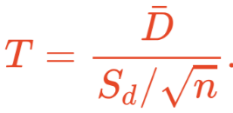 This comes from the fact that

## Two sample T-Test

### Hypothesis

H0: Two sample’s mean is identical,

H1: Two sample’s mean is different

### Assumptions

* Independent and Identically Distributed *iid*
* Population is Normally distributed around the mean
* Xi is independent from Yi
* Equal variance between two groups

## Test Statistics

## P-Val

|  |  |  |
| --- | --- | --- |
| When H1: | P(Tnx – ny - 2 ≥t0) | t.test(x,y, alternative = “greater”, var.equal = TRUE) |
| When H1: | P(Tnx – ny - 2 ≤t0) | t.test(x,y, alternative = “less” , var.equal = TRUE) |
| When H1: | P(Tnx – ny - 2 ≥|t0|) | t.test(x,y, alternative = “two.sided” , var.equal = TRUE) (default) |

## Equal Variance

Tested using **Box plot** and comparing the **Standard Deviation** of both samples

## Welch Two Sample T-Test

When Equal Variance is Not possible

## Test Statistics

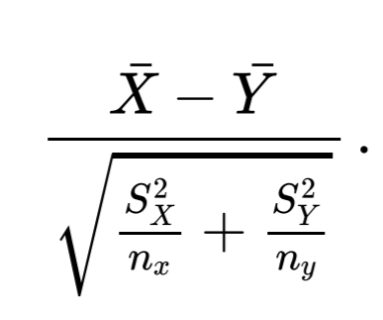

Therefore

|  |  |  |
| --- | --- | --- |
| When H1: | P(Tnx – ny - 2 ≥t0) | t.test(x,y, alternative = “greater”) |
| When H1: | P(Tnx – ny - 2 ≤t0) | t.test(x,y, alternative = “less”) |
| When H1: | P(Tnx – ny - 2 ≥|t0|) | t.test(x,y, alternative = “two.sided) (default) |

# Critical value

Critial value can be seen as a value that located at the α percentile of the

normal graph.

**Critical value** is a point of the test distribution that is compared to the

test statistics to determin whether to reject the null hypothesis or not

It can be calculated by doing

**C = qt(α, (degree of freedom))**

If two sided, α needs to be

Therefore, if α = 0.05, then either c = qt(0.025,df) or qt(0.975,df)

# T-Test

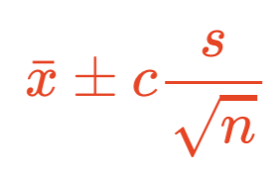Delcare H0 to be rejected if, 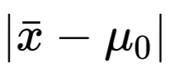 >

# Confidence Interval

### Standard Error

When trying to find the confidence interval, we use Standard Error to find the variation in expected mean range

# Coverage Probability

* Probability that the true value of the **unknown parameter** lies **inside the** confidence interval
  + **Coverage probability =** 1- α

# Rejection Region

|  |  |
| --- | --- |
| When H1: | Tn-1(α) = qt(1-α, n-1) |
| When H1: | Tn-1(α) = qt(α, n-1) |
| When H1: | Tn-1(α/2) = qt(1- |

## Power

|  |  |  |
| --- | --- | --- |
|  | H0 True | H0 False |
| Don’t Reject H0 | Correct Decision | Type 2 Error (β) |
| Reject H­0 | Type 1 Error (α) | Correct Decision |

Power is the ability to

“Reject H0 when H­0 is false”

## Factors that Effect Power

### **Sample Size (n)**

As **Sample Size (n) increase**, Power **increases**

### **Significance level (α)**

As **Significance level (α)**  **increase**, Critical Value **decrease**, and Power **Increases**

### **Sample Variance ()**

As **Sample Variance increase (),** Confidence interval & Confidence value **decrease**, and power **increase**

### **Cohen’s d, (**)/

As **Cohen’s d decrease,** power **increase**

## Pwr package

Pwr.t.test(n = , d = , sig.level = , power = ,

type = {“two.sample”,”one.sample”,”paired”},

alternative = {“two.sided”, “less”,”greater”})

if you leave one of the parameter as NULL, it will provide the corresponding parameter’s expected values

* Using this, you can find out the expected value for

# Sign Test

Goes around the t-test restriction of Normality by getting rid scaling factor.

This is only applicable for **paired t-test** or **single sample t-test**

Diff = xi – xy ­or xi -

## Hypothesis

H0: number of positive signed differences = number of negative signed differences, P+ =

H1: number of positive signed differences ≠ number of negative signed differences, P+ ≠

## Assumption

* The Differences is equally likely to be **negative** as it is **positive**
* No ties are considered

## Test Statistics

**t0 = #P+ =** number of positive differences

## P-Val

|  |  |
| --- | --- |
| When H1: | P(Tt0) |
| When H1: | P(Tt0) |
| When H1: & t0 > | 2P(Tt0) |
| When H1: & t0 < | 2P(Tt0) |

## R Code Example

binom.test(c(P+,P-), p = 0.5, alternative = “greater”)

**alternative** is refering to whether there is :

* More positive value than negative value

## Advantages

* Non-Parametric
* Robust

## Disadvantages

* Ignores a lot of information
* Less powerful than t-test

# Wilcoxon signed-rank test